John Carroll
Jcc0044/902521946
Computer Architecture
Homework 5
Theme: Cache Memory
All questions carry equal weight. You must show work to receive credit.
- What is the function of a replacement algorithm? Do you need a replacement algorithm for direct mapping?
Answer: Replacement algorithms are designed to maximize the hit ratio.
For direct mapping, there is only one possible line for any particular block, and no choice is possible. A replacement algorithm is not needed. For the associative and set-associative techniques, a replacement algorithm is needed.
- Define the two write policies in about ten sentences total. Discuss the relative merits of the policies.
Answer:
Write back: Write operations are usually made only to the cache. Main memory is only updated when the corresponding cache line is flushed from the cache. An alternative technique, known as write back, minimizes memory writes. With write back, updates are made only in the cache. When an update occurs, a dirty bit, or use bit, associated with the line is set. Then, when a block is replaced, it is written back to main memory if and only if the dirty bit is set. The problem with write back is that portions of main memory are invalid, and hence accesses by I/O modules can be allowed only through the cache. This makes for complex circuitry and a potential bottleneck. Experience has shown that the percentage of memory references that are writes is on the order of 15% [SMIT82]. However, for HPC applications, this number may approach 33% (vector-vector multiplication) and can go as high as 50% (matrix transposition).
Write through: The simplest technique is called write through. Using this technique, all write operations are made to main memory as well as to the cache, ensuring that main memory is always valid. Any other processor–cache module can monitor traffic to main memory to maintain consistency within its own cache. The main disadvantage of this technique is that it generates substantial memory traffic and may create a bottleneck. Even if a write-through policy is used, the other caches may contain invalid data. A system that prevents this problem is said to maintain cache coherency.
The strategy is to extend the MESI protocol (or any cache coherence proto- col) to the L1 caches. Thus, each line in the L1 cache includes bits to indicate the state. In essence, the objective is the following: for any line that is present in both an L2 cache and its corresponding L1 cache, the L1 line state should track the state of the L2 line. A simple means of doing this is to adopt the write-through policy in the L1 cache; in this case the write through is to the L2 cache and not to the memory. The L1 write-through policy forces any modification to an L1 line out to the L2 cache and therefore makes it visible to other L2 caches. The use of the L1 write- through policy requires that the L1 content must be a subset of the L2 content. This in turn suggests that the associativity of the L2 cache should be equal to or greater than that of the L1 associativity. The L1 write-through policy is used in the IBM S/390 SMP.

- Describe a simple way of implementing an LRU replacement algorithm in a 4-way set associative cache.
Answer:
1) Associate a 2-bit counter with each of the four blocks in a set.
2) Initially, arbitrarily set the four values to 0, 1, 2, and 3respectively.
3) When a hit occurs, the counter of the block that is referenced is set to 0. The other counters in the set with values originally lower than the referenced counter are incremented by 1; the remaining counters are unchanged.
4) When a miss occurs, the block in the set whose counter value is3 is replaced and its counter set to 0. All other counters in the set are incremented by 1.
Block frame size = 16 bytes
Number of block frames in cache = 16Kbytes/16 Bytes = 1024.
Number of sets = Number of block frames/Associativity = 1024/4 =256 sets.
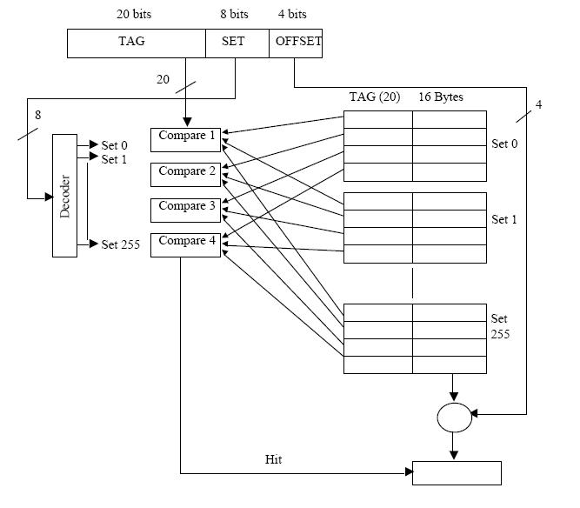

- What is the impact of the design decision of line size on hit ratio? Discuss the various approaches of cache coherency in a multiprocessor system (in about 10 sentences). Discuss the relative merits of unified vs. split (code/data) cache design.
Answer: When a block of data is retrieved and placed in the cache, not only the desired word but also some number of adjacent words are retrieved. As the block size increases from very small to larger sizes, the hit ratio will at first increase because of the principle of locality, which states that data in the vicinity of a referenced word are likely to be referenced in the near future. As the block size increases, more useful data are brought into the cache. The hit ratio will begin to decrease, however, as the block becomes even bigger and the probability of using the newly fetched information becomes less than the probability of reusing the information that has to be replaced.
Bus watching with write through: Each cache controller monitors the address lines to detect write operations to memory by other bus masters. If another master writes to a location in shared memory that also resides in the cache memory, the cache controller invalidates that cache entry. This strategy depends on the use of a write-through policy by all cache controllers.
Hardware transparency: Additional hardware is used to ensure that all updates to main memory via cache are reflected in all caches. Thus, if one processor modifies a word in its cache, this update is written to main memory. In addition, any matching words in other caches are similarly updated.
Noncacheable memory: Only more than one processor shares a portion of main memory, and this is designated as noncacheable. In such a system, all accesses to shared memory are cache misses, because the shared memory is never copied into the cache. The noncacheable memory can be identified using chip-select logic or high-address bits.
For a given cache size, a unified cache has a higher hit rate than split caches because it balances the load between instruction and data fetches automatically. That is, if an execution pattern involves many more instruction fetches than data fetches, then the cache will tend to fill up with instructions, and if an execution pattern involves relatively more data fetches, the opposite will occur. Only one cache needs to be designed and implemented.
- Define spatial and temporal locality.
Answer:
Spatial locality refers to the tendency of execution to involve a number of memory locations that are clustered. This reflects the tendency of a processor to access instructions sequentially. Spatial location also reflects the tendency of a pro- gram to access data locations sequentially, such as when processing a table of data. Temporal locality refers to the tendency for a processor to access memory locations that have been used recently. For example, when an iteration loop is executed, the processor executes the same set of instructions repeatedly.

Consider the following code:
for (i=0; i < 50; i++)
for (j =0; j < 30; j++)
a[i] = a[i] * j;
- Give an example of spatial locality in the above code.
Answer: The principle of Temporal locality states that two instructions reference the same location within a relatively short timeframe. For example, in the code given, a[i] is referenced frequently, with instructions like a[i] = a[i] * 2 and a[i] = a[i] * 3 being executed very close together. If we are looking at this scope, we could say that references to j and a[i]are temporally local. References to i are also temporally local, because i is referenced every time a[i] is. However, if the last line of the given code read something like a[j] = a[j] * j, then references to i would not be temporally local, at least in the scope of the inner loop^{[1]}.
- Give an example of temporal locality in the above code.
Answer: The principle of Spatial locality states that two instructions reference contiguous memory locations. References to a[i] are a good example of this, as one can assume (most of the time) that a[0] and a[1] will be next to each other in memory.

- Consider a memory system with the following parameters:
Tc = 10ns, Cc= $10⁻⁵/bit
Tm = 120ns, Cm = $10⁻⁶/bit
- What is the cost of 4 GB of main memory?
10^-6*4*8*10^9 = $32,000
- What is the cost of 4 GB of main memory using cache only technology?
10^-5*4*8*10^9 = $320,000
- If the effective access time is 15% greater than cache access time, what is the hit ratio H?
(10 + 120 - 1.5)/120 = 1.07
- A computer has cache, main memory and a disk used for virtual memory. If a referenced word is in the cache, 20 ns are required to access it. If it is in the main memory, but not in the cache 60 ns are needed to load into the cache, and then the reference is started again. If the word is not in the main memory, 12 ms are required to fetch the word from the disk, followed by 60 ns to copy it to the cache, and then the reference is started again. The cache hit ratio is 0.9 and the main memory hit ratio is 0.6. What is the average time in ns required to access a referenced word on this system?
90% (.9) is the time it is in cache. .10% * 60% (.06) is the time it is not in cache but is in memory. 4% (.04) (obtained from 1-90% - 6%) of the time it is neither in cache or memory

.9 (20ns) + .06 (60 ns + 20ns) + .04 (12ms + 60ns +20ns) 18ns + 4.8ns + .48ms (I've dropped the rest because it is minimal compare to the access to disk) = 480 microseconds

